ÔN TẬP TIẾNG ANH LỚP 4 THEO UNIT
UNIT 12: WHAT DOES YOUR FATHER DO?
Ex 1: Put a suitable word under each picture: farmer, nurse, driver, factory worker, teacher, student, pupil, clerk
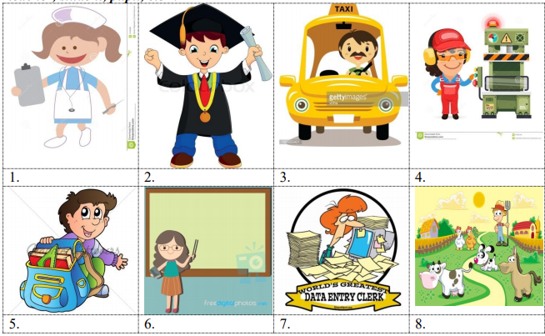
Ex 2: Odd one out:
1. a. farmer | b. month | c. nurse | d. teacher
2. a. doctor | b. hospital | c. school | d. nurse
3. a. ruler | b. worker | c. rubber | d. book
4. a. father | b. mother | c. teacher | d. grandma
5. a. pupil | b. notebook | c. pencil | d. rubber
6. a. forty | b. fourth | c. fifteen | d. twenty
7. a. get | b. go | c. stay | d. early
8. a. where | b. what | c. went | d. how
9. a. did | b. goes | c. got | d. drew
10. a. factory | b. clerk | c. school | d. hospital

11. a. office | b. police | c. doctor | d. clerk
12. a. sister | b. farmer | c. worker | d. singer
13. a. grandpa | b. grandma | c. pupil | d. uncle
14. a. read | b. at | c. to | d. past
15. a. dinner | b. eat | c. lunch | d. breakfast
16. a. morning | b. evening | c. afternoon | d. singing
17. a. finish | b. start | c. listen | d. homework
18. a. milk | b. in | c. on | d. at
19. a. field | b. doctor | c. hospital | d. factory
20. a. she | b. her | c. his | d. your
Ex 3: Find and correct the mistake:
1. I go to school at 6.40 o’clock.
2. My school finish at 11.30.
3. What do your sister do? – She’s a pupil.
4. My father water the flowers yesterday morning.
5. He goes on bed at 9.45.
6. My mother gets up early on the morning.
7. Mr. Tuan is a doctor. He works in the field.
8. Her grandfather plants rice, vegetable and raises pig, chicken. He is a factory worker.
9. Mr. Lien teaches English at my school. She is a pupil.
10. There is four people in my family: my father, my mother, my brother and me.
Ex 4: Read and match:
1. What time did you go to school yesterday? | a. It’s on the second of April. | 1.
2. What time does she have breakfast? | b. I work in a factory. | 2.
3. Were you at the zoo this morning? | c. At 9 p.m. | 3.
4. Where does your mother work? | d. No, he’s a student. | 4.
5. Where do you work? | e. She’s a clerk. | 5.
6. What time is it now? | f. At 6.30 a.m. | 6.
7. What does your mother do? | g. I went to school at 7.00. | 7.
8. What time do you go to bed? | h. It’s half past ten. | 8.
9. Is your brother a farmer? | i. No, I wasn’t. I stayed at home. | 9.
10. When’s her birthday? | k. She works in an office. | 10.
Ex 5: Make sentence using given words:
1. Nam and Quang/ student
2. Her uncle/ driver
3. My father and her uncle/ factory worker
4. My mother/ nurse
5. Mr. Huong/ doctor
6. I/ teacher
7. Mr. Nam/ go to work/ 6.45
8. We/ get up/ 6.00
9. What/ her sister/ do/ ? – She/ student/.
10. What time/ Peter/ do homework/? - / 7/ evening/.
11. A doctor/ work/ hospital/
12. A clerk/ work/ office/
13. A worker/ work/ factory/
14. A teacher/ teach/ school/
15. She/ read/ a book/ now/
Ex 6: Answer questions about you:
1. What do you do?
2. What time do you get up?
3. What time do you go to bed?
4. What time do you have lunch?
5. What does your father do?
6. Where does your father work?
7. What subjects do you like?
8. When’s your birthday?
9. What can you do?
10. When do you have English?

ĐÁP ÁN
Đáp án 1:
1 - nurse | 2 - student | 3 - driver | 4 - factory worker
5 - pupil | 6 - teacher | 7 - clerk | 8 - farmer
Đáp án 2:
1 - b | 2 - c | 3 - b | 4 - c | 5 - a
6 - b | 7 - d | 8 - c | 9 - b | 10 - b
11 - a | 12 - a | 13 - c | 14 - a | 15 - b
16 - d | 17 - d | 18 - a | 19 - b | 20 - a

Đáp án 3:
1 - bỏ o' clock | 2 - finish thành finishes | 3 - do your thành does your | 4 - water thành watered | 5 - on thành to
6 - on thành in | 7 - field thành hospital | 8 - factory worker thành farmer | 9 - pupil thành teacher | 10 - is thành are

Đáp án 4:
1 - g | 2 - f | 3 - i | 4 - k | 5 - b
6 - h | 7 - e | 8 - c | 9 - d | 10 - a

Đáp án 5:
1 - Nam and Quang are student.
2 - Her uncle is a driver.
3 - My father and my uncle are factory workers.
4 - My mother is a nurse.
5 - Mr. Huong is a teacher.
6 - I am a teacher.
7 - Mr. Nam goes to work at 6.45.
8 - We get up at 6.00 o'clock.
9 - What does her sister do? - She is a student.
10 - What time does Peter do homework? - At 7 o'clock in the evening.
11 - A doctors works in the hospital.
12 - A clerk works in the office.
13 - A worker works in the factory.
14 - A teacher teaches at the school.
15 - She is reading a book now.
Đáp án 6: Học sinh tự trả lời.
1 - I am a pupil.
2 - I get up at 6.30.
3 - I go to bed at 9.30.
4 - I have lunch at 12 o'clock.
5 - He is a farmer
6 - He works in the field.
7 - I like English.
8 - It is on the twenty - first of December.
9 - I can dance.
10 - I have it on Monday and Friday.

